The Examination of Surface Anisotropy in Ferromagnetic Resonance Measurement
E. Gokce Polat ^{1 ,2*} , Y. Li ¹, W.Cao¹, and W. E. Bailey ¹
¹ Dept. of Applied Physics & Applied Mathematics, Columbia University,
New York NY 10027, USA
²Department of Engineering Physics, Istanbul Medeniyet University,Istanbul 34720, Turkey

Abstract— We examined the uniform and first spin wave mode of permalloy thin films Ni₇₉Fe₂₁ (Py). Surface anisotropies in ferromagnetic thin films might be estimated through spin-wave resonance (SWR). It is apparent from results that (surface anisotropy) K_{s} = 0.12 mJ/ m² for Py/Cu, by using difference of exchange field in normal and parallel measurement of FMR.

In this study, the samples with the structure “Si/SiO₂ /Ta(5nm)/ Cu(5nm)/ FM(t)/ Cu(5nm)/ Ta(5nm)” (FM = Ni₇₉Fe₂₁ (Py)) were deposited by UHV magnetron sputtering with a base pressure of 5×10⁻⁹ Torr. The samples were magnetic characterized by field-swept, variable frequency FMR over 2-26 GHz using a coplanar waveguide with biasing field H_{B} applied normal to the sample surface (n.c.) and parallel to film plane (p.c.). We measured uniform and first (p = 0, 1) perpendicular standing spin-wave mode (PSSW) in films. There were differences between uniform and PSSW resonance mode, which are exchange fields Hex. And Hex was decreasing depend on thickness.

The most common method to find surface anisotropy is uniform mode FMR measurement of M_{eff} and 1/t to fitting [4]. It can be seen from the Figure-1 that M_{eff} reduces when t decreases for each geometry conditions of FMR. Therefore, there is perpendicular surface anisotropy (K_{s}>0). Due to this fitting type, we find that normal condition is K_{s}=0.14 mJ/ m² and parallel condition is K_{s}=0.12 mJ/ m².
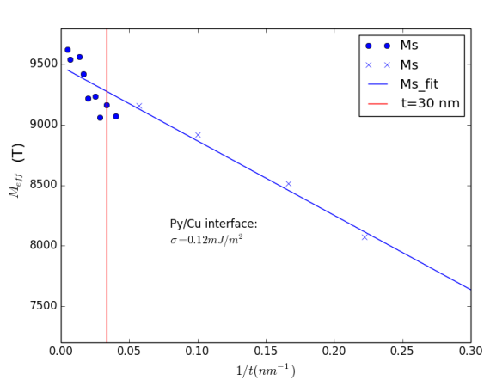
Figure-1: p.c. FMR measurement of M_{eff} for Ta/Cu/Py[t]/Cu/Ta.

Existing theory[1] suggests that exchange field in the pc and nc geometries are equal only in the case of zero surface anisotropy. If there is surface anisotropy in thin film, surface boundary conditions would changed, and pinning parameter will be proportional to surface anisotropy for top and bottom surface. Thus, it gives a different value of the wave vector k by using tangential equation. For same sample, we observed that the exchange field is larger for n.c. than for p.c., because of that there is no effect of surface anisotropy for one of the processional directions in pc. The FMR frequency for the normal and p.c. condition resonances are given by equation 1 and 2.
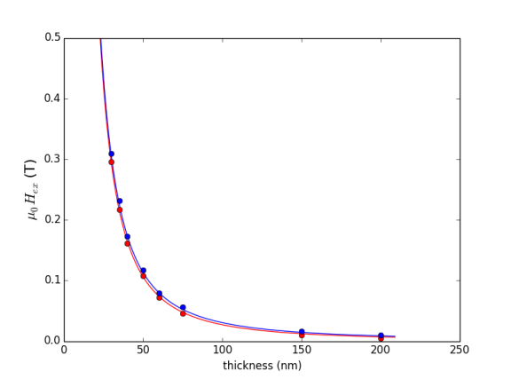
Figure-2: Exchange fields are the function of t for Py. Blue/Red dots are measurement n.c. and p.c. data. Blue/Red lines are fits by using equation 1 and 2.
(Equation 1)
(Equation 2)
We fitted Exchange field data by using eq.1 and eq.2, and found that surface anisotropy is 0.12±0.10 mJ/ m². This result nicely shows the surface anisotropy of films which has quite similar results of M_{eff} slope method. Current study provides that the exchange fitting method can be useful for check find out surface anisotropy value.

*Corresponding author: eg2750@columbia.edu.
[1] B. A. Kalinikos and A. N. Slavin, “Theory of dipole-exchange spin wave spectrum for ferro-magnetic films with mixed exchange boundary conditions” Journal of Physics C: Solid State Physics, vol. 19, pp. 7013-7033 (Dec 1986).
[2] G. Rado and J. Weertman, “Spin-wave resonance in a ferromagnetic metal” Journal of the Physics and Chemistry of Solids, vol. 11, no. 3-4, pp. 315-333 (1959).
[3] Kittel, C. “On the Theory of Spin Waves in Ferromagnetic Media.”Phys. Rev. B 11, 2624-2637 (1975).
[4] A. Ghosh, J. F. Sierra, S. Auffret, U. Ebels, and W. E. Bailey, “Dependence of nonlocal Gilbert damping on the ferromagnetic layer type
in ferromagnet/Cu/Pt heterostructures.” Applied Physics Letters 98, 052508 (2011).

